***Mandatory Project Week-3***

***-Nishita Singh***

***USE IG_clone database:***

1. Create an ER diagram or draw a schema for the given database.

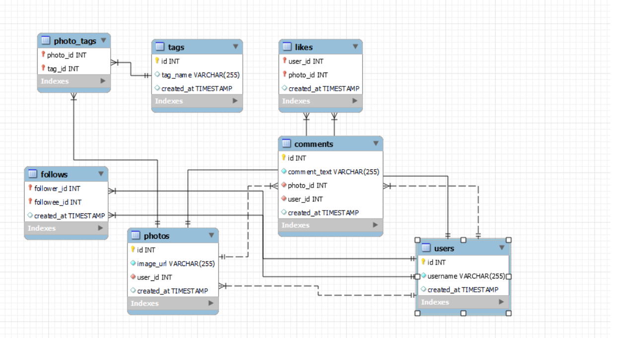

***2.*** We want to reward the user who has been around the longest, Find the 5 oldest users.

***use ig_clone;***

***Select * from users order by created_at asc limit 5;***

3. To target inactive users in an email ad campaign, find the users who have never posted a photo.

***Select * from photos;***

***use ig_clone;***

***select user_id from photos;***

***Select id,username from users where id not in (select user_id from photos);***

4. Suppose you are running a contest to find out who got the most likes on a photo. Find out who won?

***Select * from likes;***

***create temporary table most_likeed as(Select photo_id,count(l.photo_id) as max_likes from likes l group by photo_id order by max_likes desc limit 1);***

***select p.id,user_id,username from photos p join most_likeed ml on p.id=ml.photo_id join users u on u.id=p.user_id;***

5. The investors want to know how many times does the average user post.

***Select(Count(Distinct user_id)) as average_posts from photos;***

***select count(*) from photos;***

***Select Count(*) / Count(Distinct user_id) AS average_posts***

***From photos;***

6. A brand wants to know which hashtag to use on a post, and find the top 5 most used hashtags.

***Select * from tags;***

***select tag_id,tag_name,count(tag_name) as max_tag from tags t join photo_tags pt on***

***t.id=pt.tag_id group by tag_id,tag_name order by max_tag desc,tag_id limit 5;***

***\*\*By including tag_id as a secondary sorting criteria, we are instructing the database engine to prioritize the rows with the highest frequency (max_tags) and, within those rows, order them by the tag_id in ascending order. This will result in a deterministic and consistent ordering of the tied rows.***

7.To find out if there are bots, find users who have liked every single photo on the site.

***select * from likes;***

***select username from users u where u.id in (select l.user_id from likes l group by l.user_id***

***having count(distinct l.photo_id)= (select count(*) from photos));***

8.Find the users who have created instagramid in may and select top 5 newest joinees from it?

***Select * from users;***

***select username,created_at from users where month(created_at)=5 order by created_at desc limit 5;***

9. Can you help me find the users whose name starts with c and ends with any number and have posted the photos as well as liked the photos?

***select * from users where username regexp '^c' and username regexp '[0-9]$' and id in***

***(select user_id from photos p where user_id in (select user_id from likes l));***

10. Demonstrate the top 30 usernames to the company who have posted photos in the range of 3 to 5.

***select * from users u where id in (Select user_id from photos p group by user_id having count(*) between 3 and 5) order by username asc limit 30 ;***

Thankyou!!